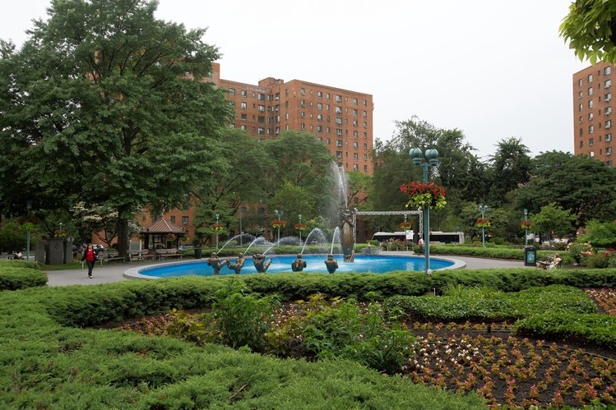Kenneth DelCastillo

Professor St. John

MHC 250

February 3rd, 2017

**Parkchester**

ZIP: 10462

Census Tract: 0210, 020602, 0212, 021602

Population: 18,431

Parkchester

Population Density: 49,850 per square mile

59% Hispanic 31% Black 6% Asian 5% Other

32% Are Foreign Born

By Age: 25% 0-17, 11% 18-24, 28% 35-44, 24% 45-64, 11% 65+

24% College grad, 46% High School grad, 30% less than High School

29% Proverty, 14% Unemployed, 54% Rent Burdened

White Collar employed: 8,653

Blue collar employed: 4,394

Median Household income (2015): $41,075

Distance to Empire State Building:

8.53 Miles/ 13.74 Kilometers

Distance to Federal Hall:

11.87 Miles/ 19.11 Kilometers

CITATIONS

**"Bronx Community District 9: Parkchester and Soundvie." *Nyc.gov*. NYC HEALTH, 2015. Web. 7 Feb. 2017.**